**[Insert Task Number and Title]**

* A stochastic optimal control algorithm was developed to improve the robustness of human-engineered rules used previously in the Advanced Airspace Concept for use with the UAS Traffic Management (UTM) program. The algorithm provides short-term conflict resolution that balances aircraft safety with efficiency subject to uncertainty in the environment, aircraft, and pilot response for aircraft operating under UTM. This algorithm is implemented in a prototype server running a massively distributed software architecture to provide conflict resolution as a service on a practical scale.
* The conflict resolution algorithm is developed on a Markov decision process formulation of the short-term conflict resolution problem. To solve a large multi-aircraft problem in the context of UTM’s operation, the algorithm decomposes the multi-agent problem into tractable subproblems and produces joint advisories for aircraft in potential conflict by coordinating solutions to these subproblems. The effectiveness of the algorithm was tested via numerical simulation against two baseline algorithms based on closest-threat and uncoordinated heuristics. The simulation results demonstrated that our work significantly outperformed the baselines. This work was awarded the best graduate student paper at the 34th IEEE/AIAA Digital Avionics Systems Conference.

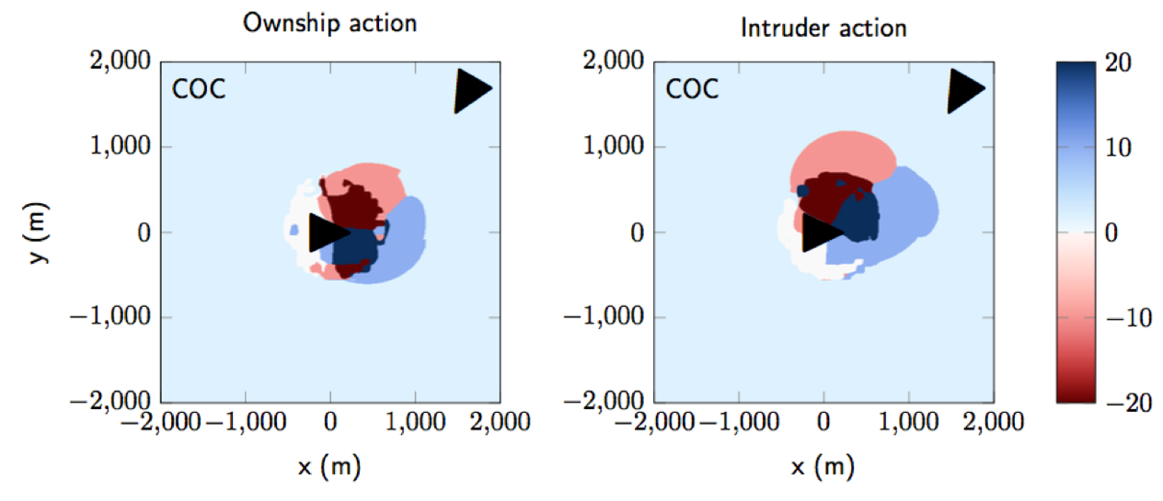

**Fig. 1. Example advisory plot for two-aircraft conflict; colors represent turn rates.**

* The distributed conflict resolution service is designed as a "special" UTM client that queries for data and never submits anything directly to UTM. Client operators would subscribe to our endpoint and receive the notifications through a pub-sub system, as is illustrated in Fig. 2. As the architecture was designed to be modular with respect to the algorithm, the algorithm can be swapped out for other algorithms that provide other services to clients (e.g., path planning services prior to flight). Future developers can refer to the extensive documentation on how to use the architecture’s source code for their work.



**Fig. 2. Distributed architecture for conflict resolution.**

**Exact Decoupled Hamilton-Jacobi Formulation:** In reachability analysis, one is interested in computing the reachable set, defined as the set of states from which there exists a control, despite the worst disturbance, that can drive the system into a set of target states. The target states can be used to model either desirable or undesirable configurations, depending on the application. However, due to the exponential complexity scaling in computation time and space, problems involving approximately 5 dimensions become intractable. In this work, we eliminate complexity-optimality trade-offs for time-invariant decoupled systems using a decoupled Hamilton-Jacobi formulation that enables the exact reconstruction of high dimensional solutions via low dimensional solutions of the decoupled subsystems. Our formulation is compatible with existing numerical tools. The figures below show the accuracy and computation benefits of our method.



**Safe Platooning of UAVs via Reachability:** Hamilton-Jacobi (HJ) reachability is a powerful framework for providing conditions under which UAV safety and liveness requirements can be met, and for synthesizing the optimal controller for meeting them. However, due to the curse of dimensionality, HJ reachability is only tractable for a small number of vehicles if their set of maneuvers is unrestricted. In this work, we define a platoon to be a group of UAVs in a single-file formation. We model each vehicle as a hybrid system with modes corresponding to its role in the platoon, and specify the set of allowed maneuvers in each mode to make the analysis tractable. We propose several liveness controllers based on HJ reachability, and wrap a safety controller, also based on HJ reachability, around the liveness controllers. For a single altitude range, our approach guarantees safety for one safety breach; in the unlikely event of multiple safety breaches, safety can be guaranteed over multiple altitude ranges. The figures below show the hybrid model of a vehicle, and a simulated scenario where a platoon meets an intruder vehicle.

